**Book Marketplace Project**

By:…………………………………



Delhi Public School - Bopal, Ahmedabad

**CERTIFICATE**

This is to certify that ____ ___________ student of Class XII Z has successfully completed project on the topic **Book Marketplace** under the guidance of Ms. Malvika Sharma, during the Academic year 2023-2024, for partial fulfilment of Computer Science (083), Practical Examination conducted by AISSCE 2023-2024.

Subject: Computer Science (083)

Board Roll number: __________________

Subject Teacher Examiner

Date: ___________

**Index**

1. Acknowledgement____________________3
2. Introduction_______________________4
3. System Specifications______________5
4. Database Structure_________________6
5. Python Code________________________7
6. Output____________________________37
7. Conclusion________________________40
8. References________________________41

**Acknowledgement**

I extend my sincere gratitude to my dedicated Computer Science teacher, Ms. Malvika Sharma, whose guidance was pivotal in the successful completion of my Class 12 project. She not only shared valuable insights but also provided unwavering support, fostering an environment where I could explore and apply complex concepts with confidence.

Ms. Malvika Sharma exhibited a remarkable balance of encouragement and constructive critique, significantly enhancing the depth and quality of my project. The commitment to our learning journey and the accessibility to address queries played a crucial role in shaping my understanding of the subject.

Completing this project under Ms. Malvika Sharma’s mentorship has been an enriching experience, offering not only academic insights but also instilling a passion for the field. I am grateful for her dedication and the positive impact she has had on my educational trajectory.

…………………………………………

**Introduction**

This project presents a Book Marketplace that provides a digital platform to view and purchase books. Our project aims to showcase the application of fundamental Python and Database management principles.

This project allows the user to sign up for an account and access the functions of this application. At the back end of the project, it consists of a database with two tables related to user information and book information. The project is also presents a neat user interface.

**System Specifications**

1. ***Hardware:***

* **CPU:** Intel® Core™ i5-10400T @2.00GHz
* **Memory:** 8.0 GB
* **GPU:** Intel® UHD Graphics 630

1. ***Software:***

* **OS:** Windows® 11
* **Development tools:** Python, SQLite, written in VS Code

**Database Structure**

**Database Design:**

The database consists of two tables; one for User information and the other for Books information. The information about the field datatypes and keys can be viewed in the graphic shown below:

**File Name: database.db**

**Python Code**

File: main.py

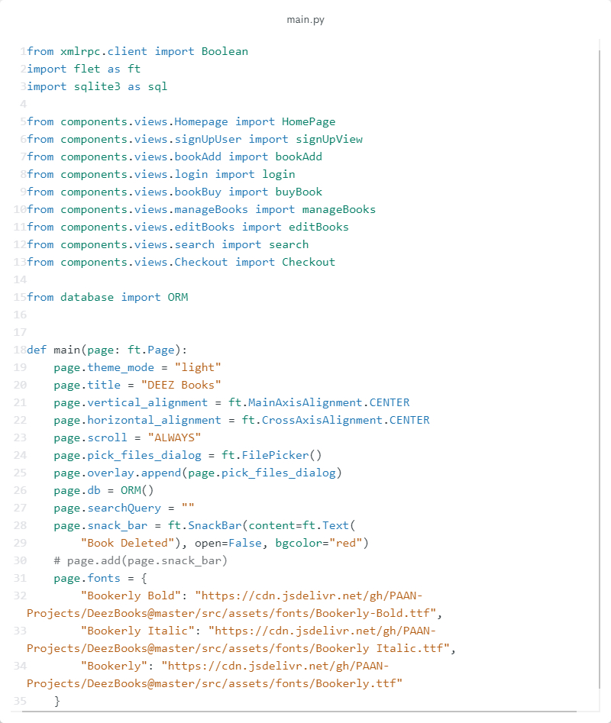

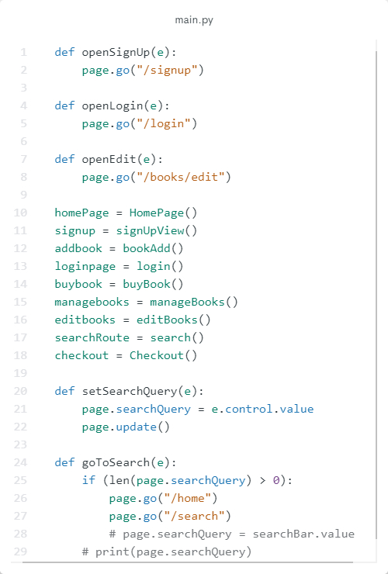

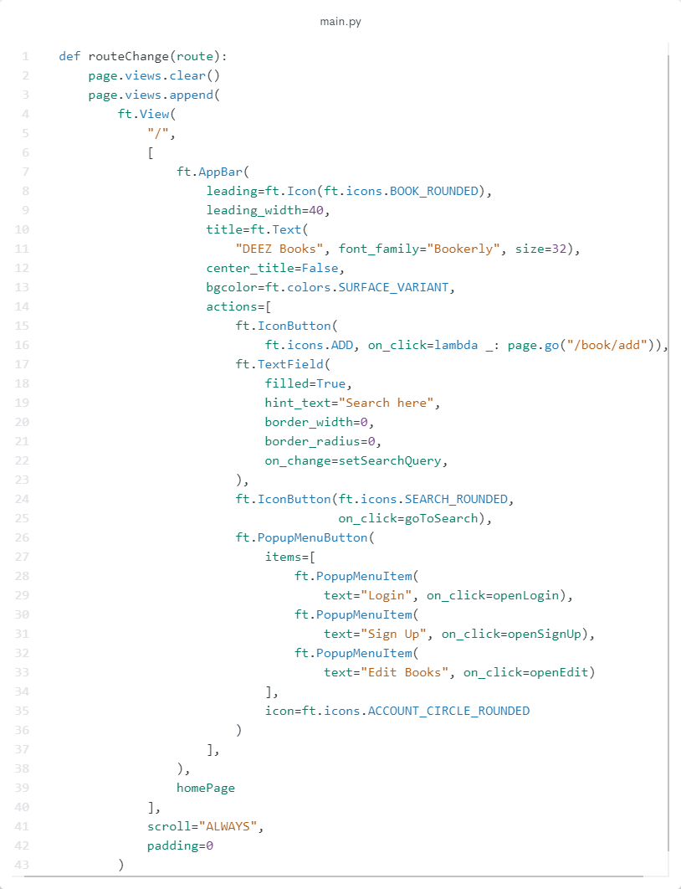

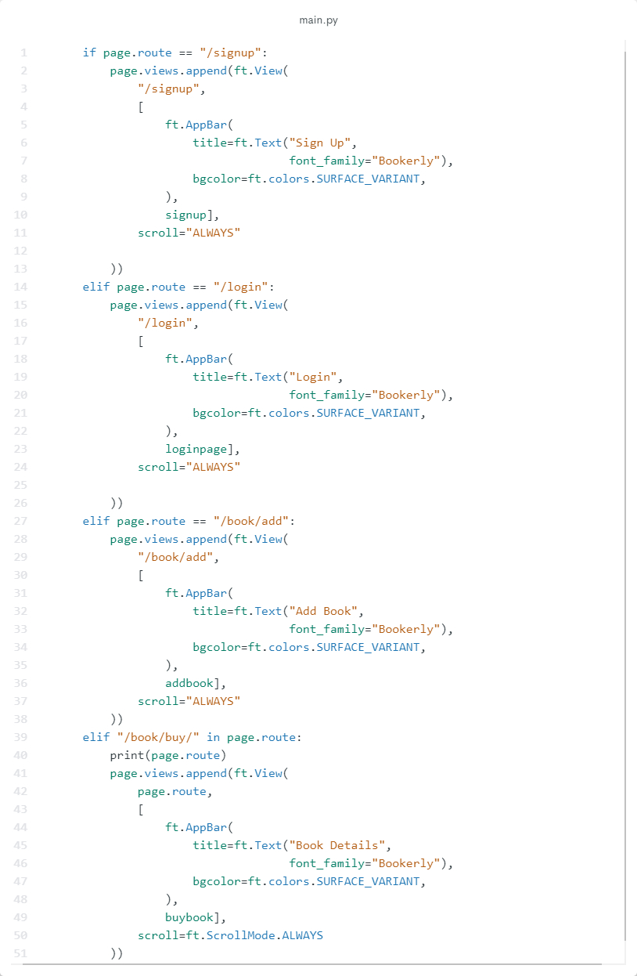

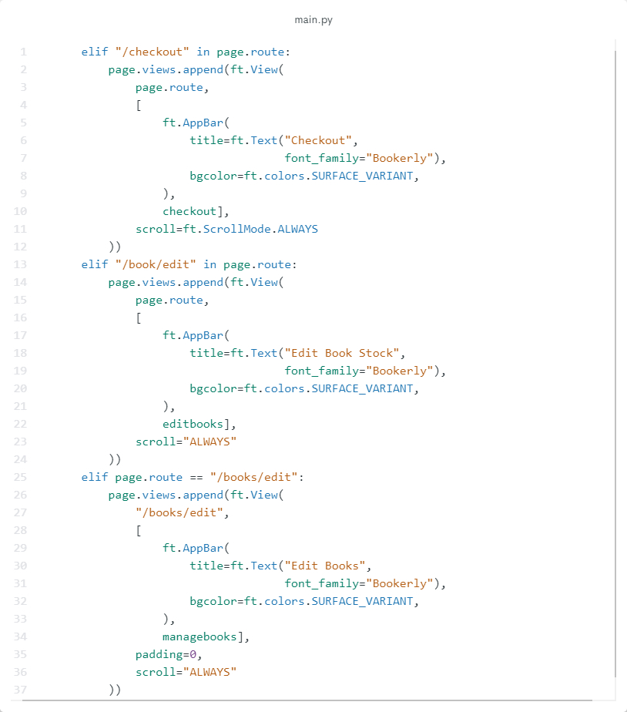

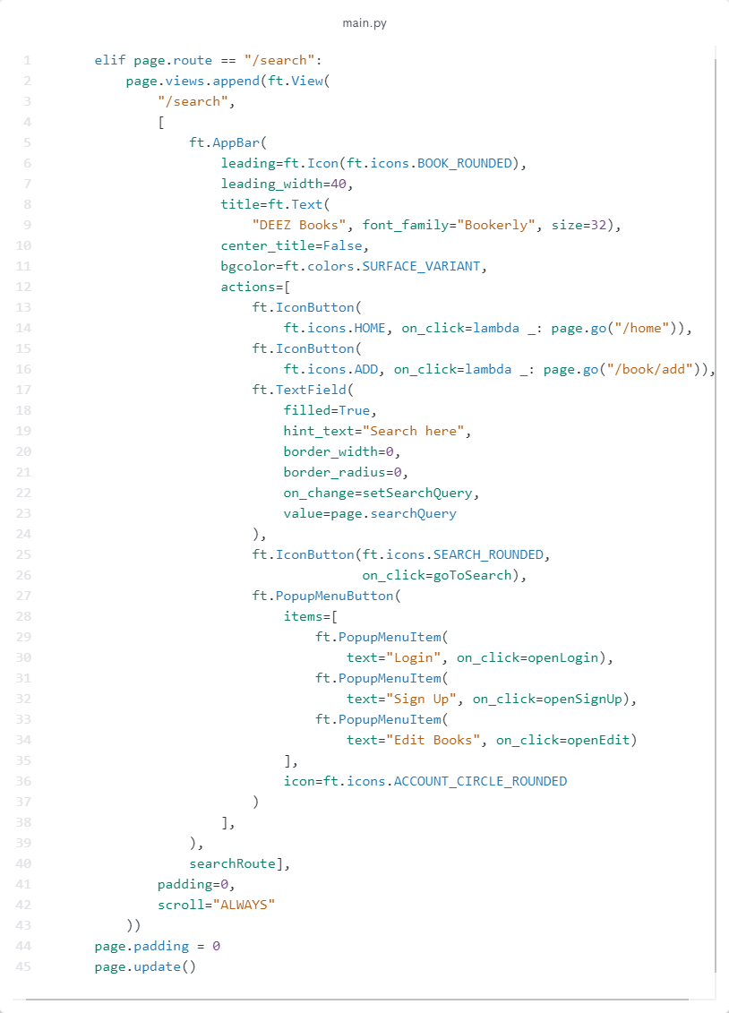

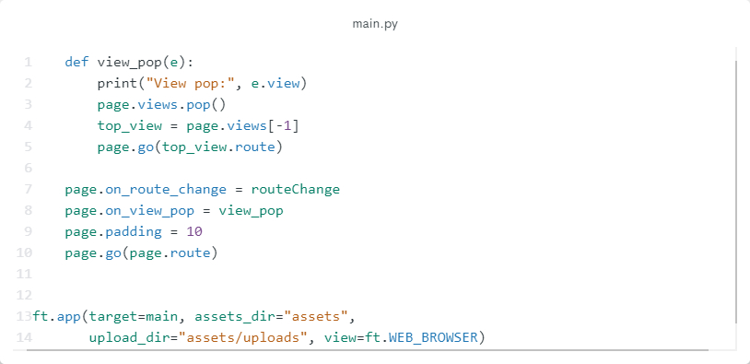

File: bookAdd.py

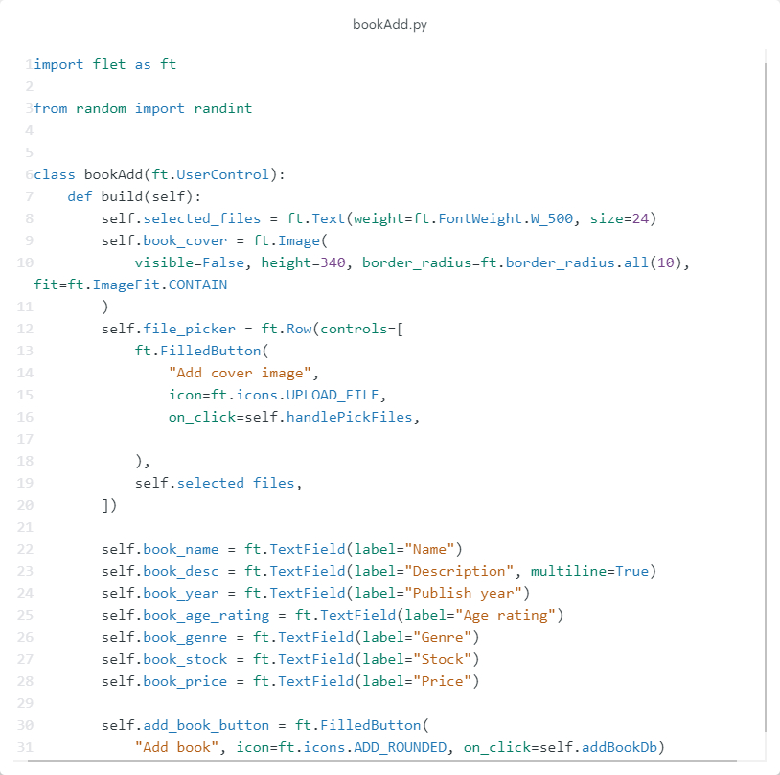

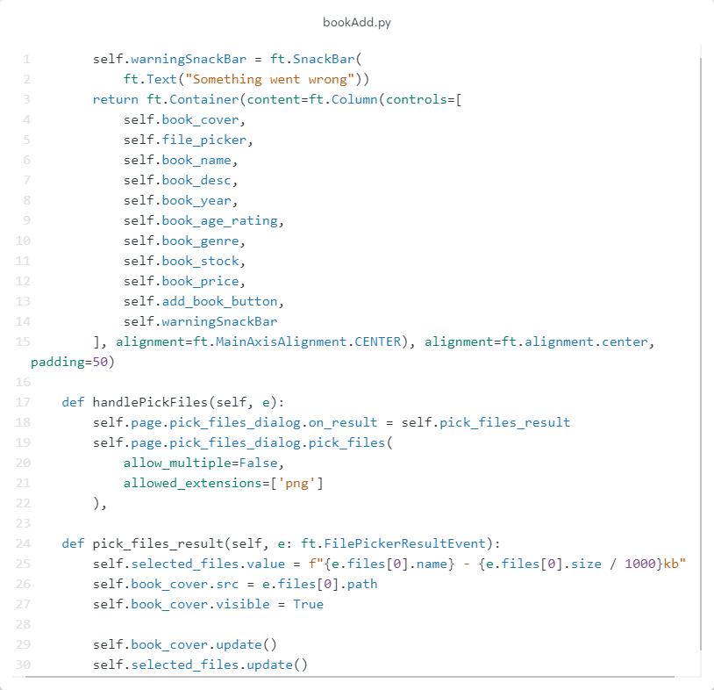

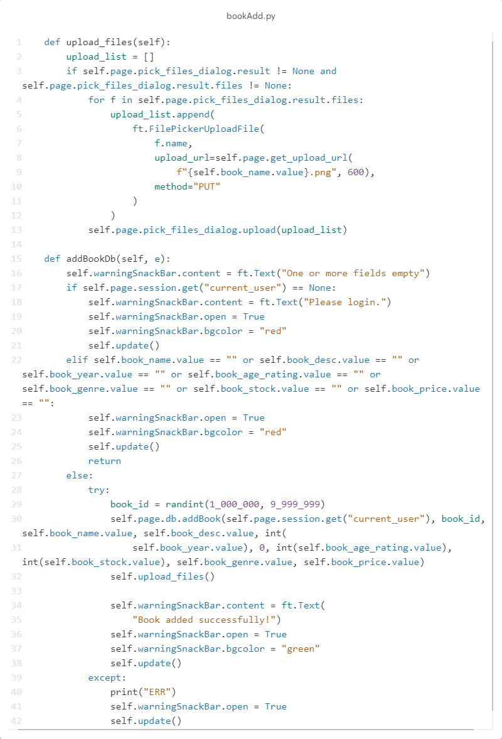

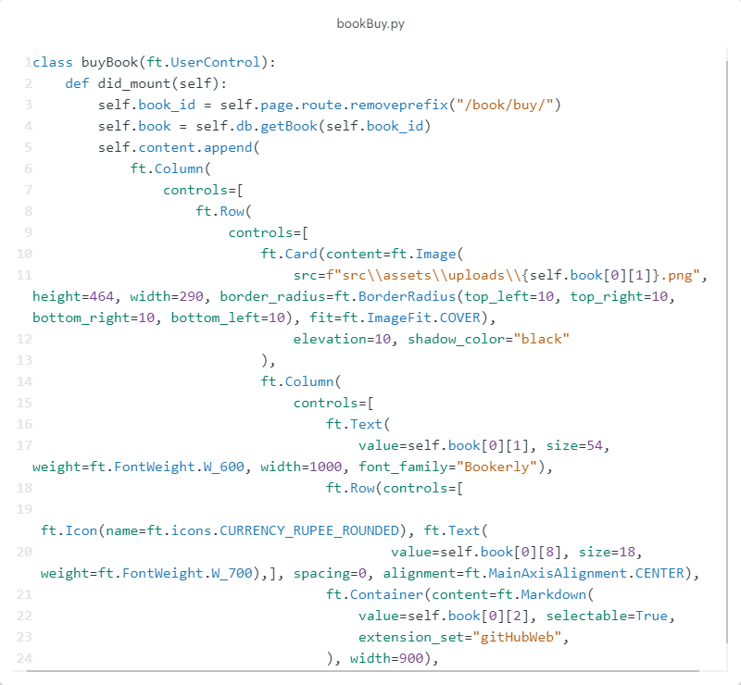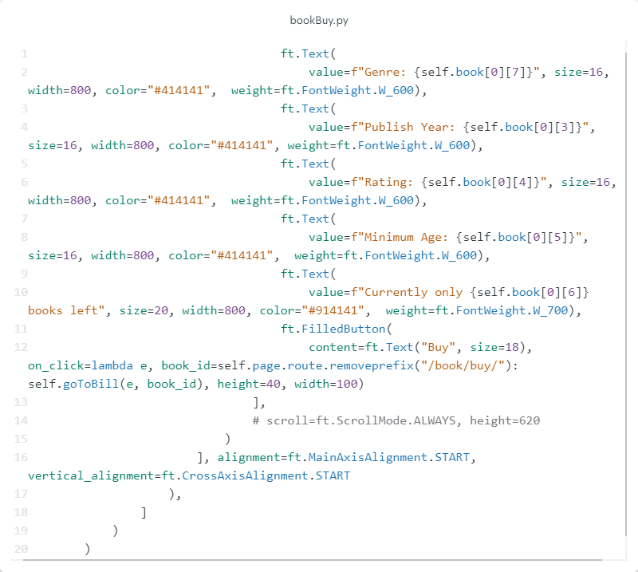

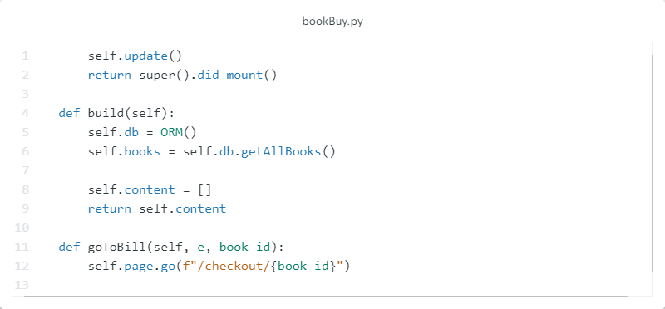

File: Checkout.py

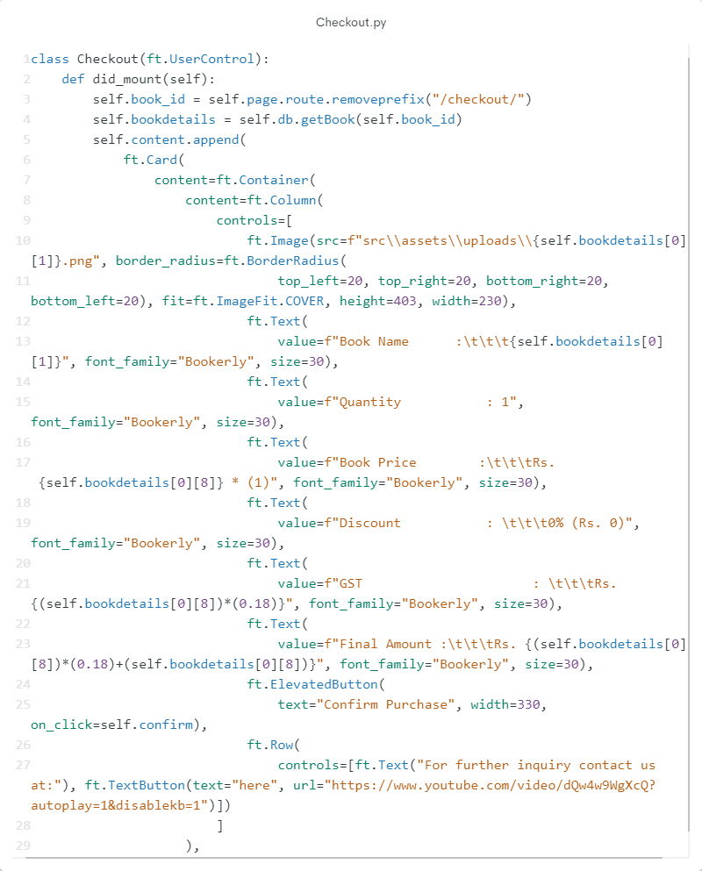

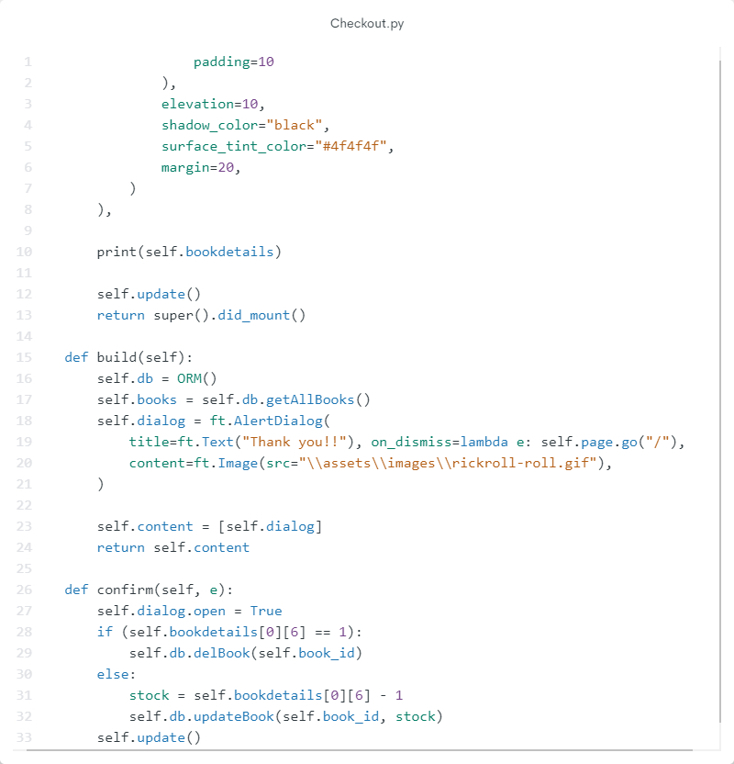

File: editBooks.py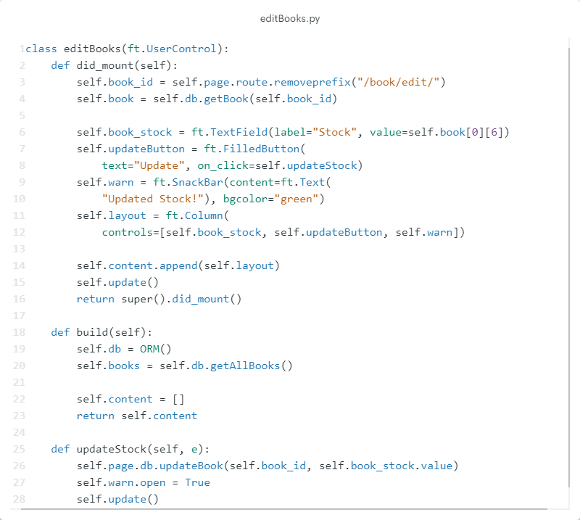

File: Homepage.py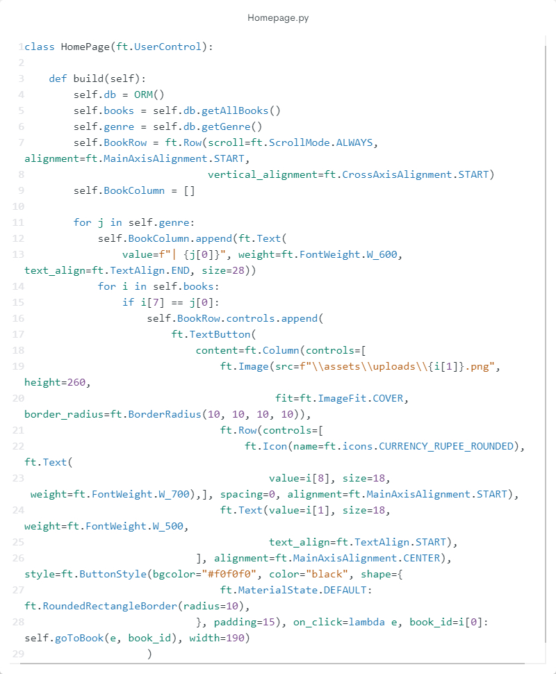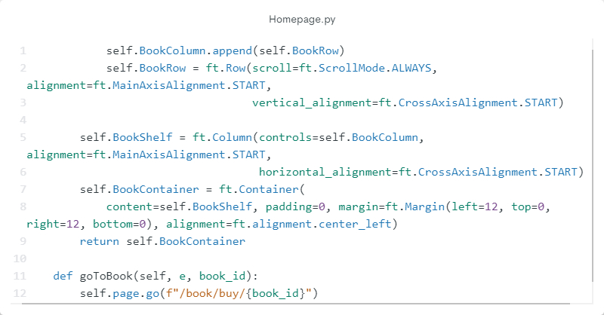

File: login.py

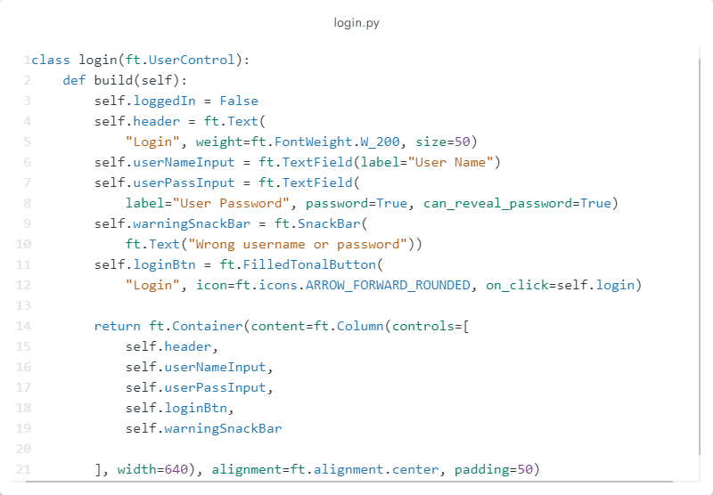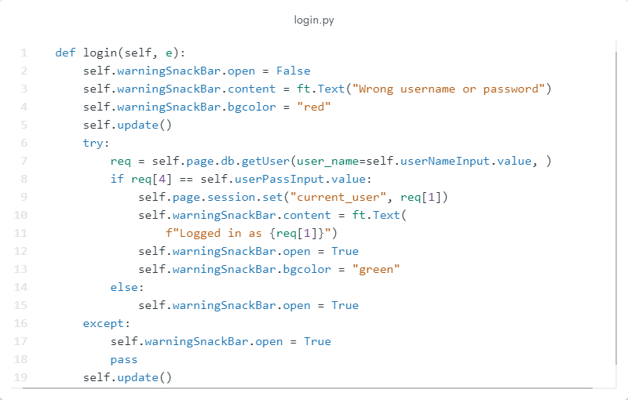

File: manageBooks.py

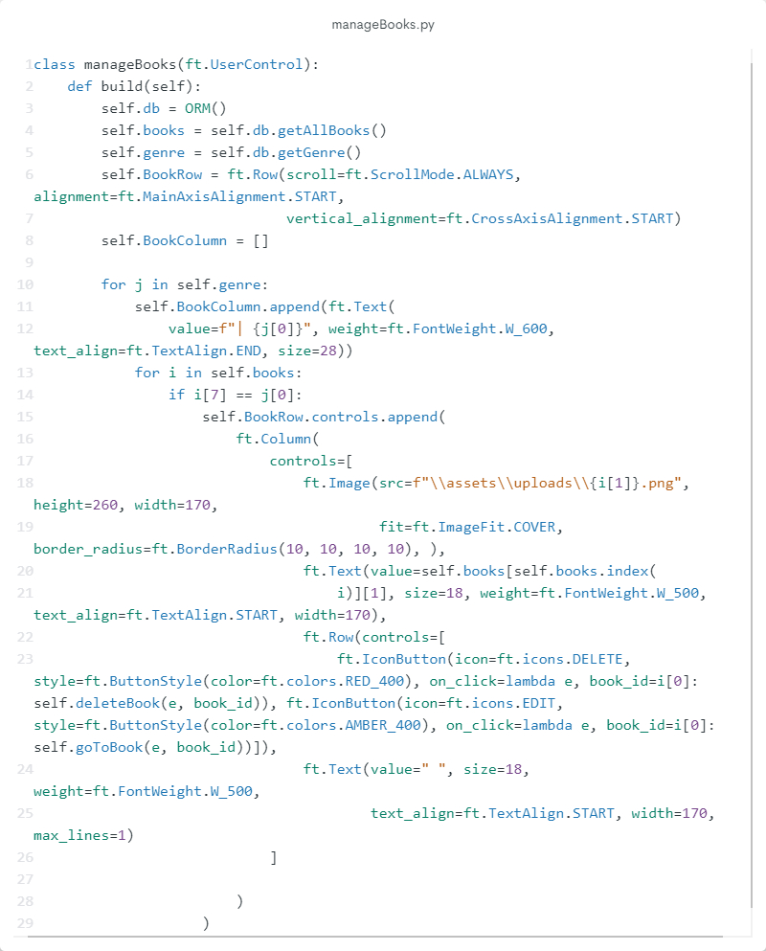

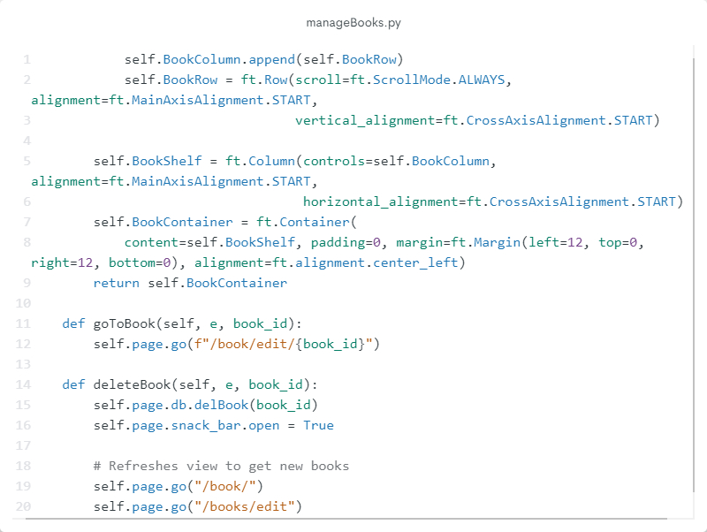

File: search.py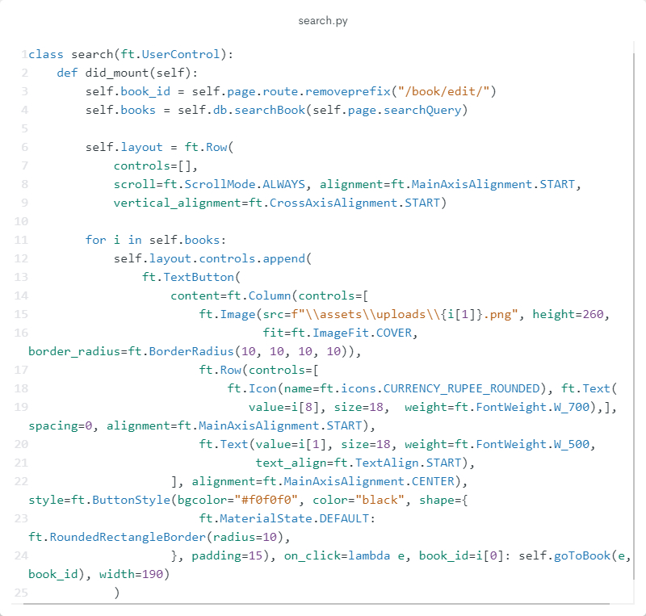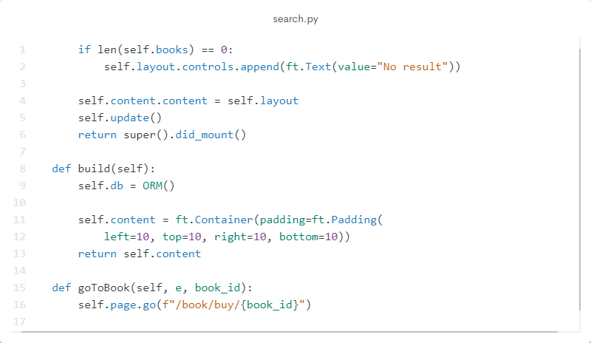

File: signUpUser.py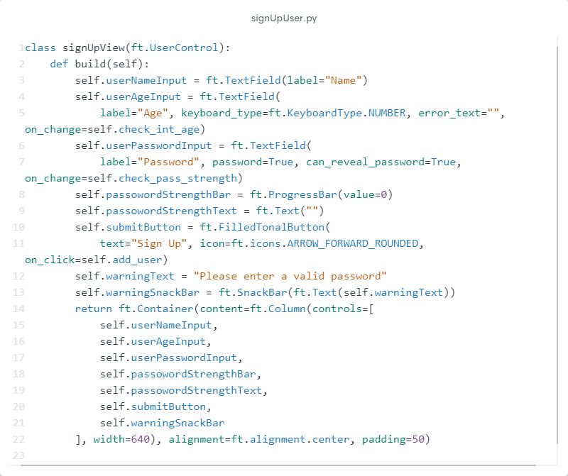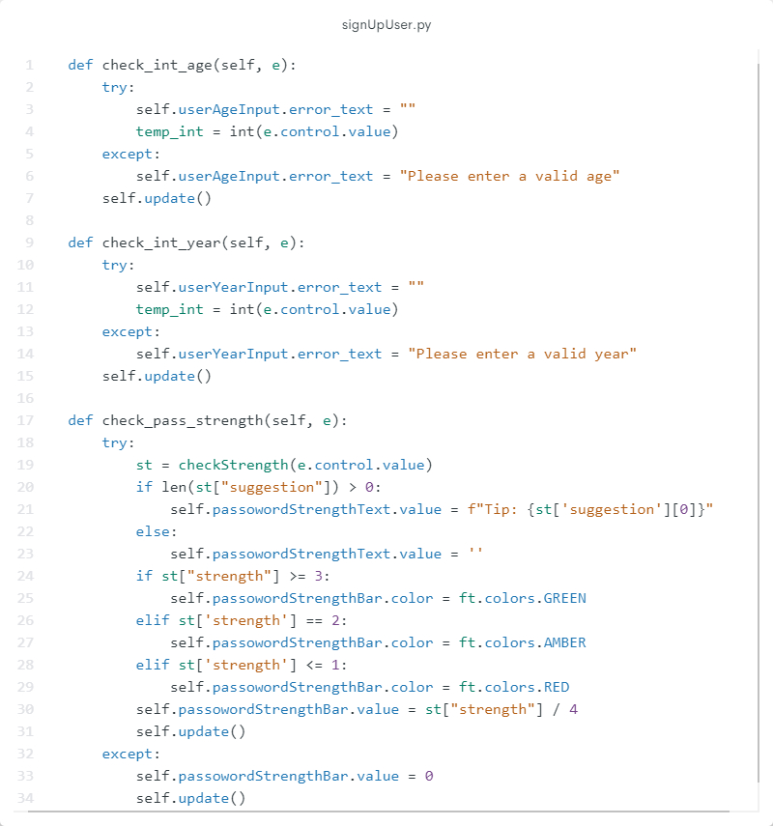

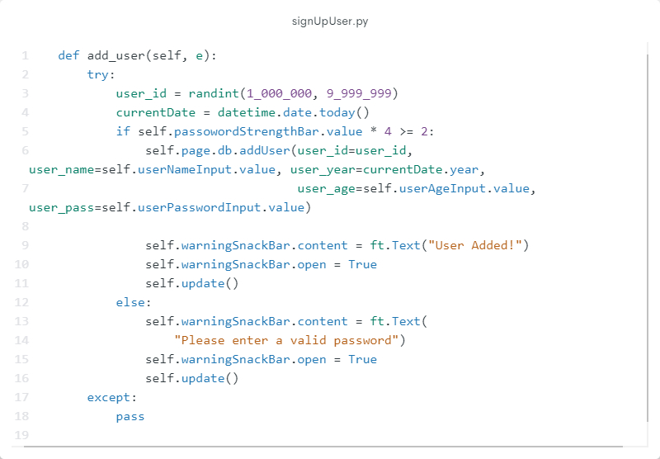

File: password.py

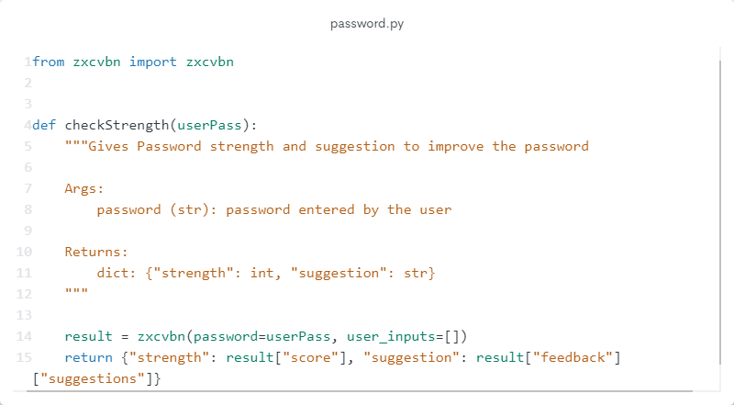

File: database.py

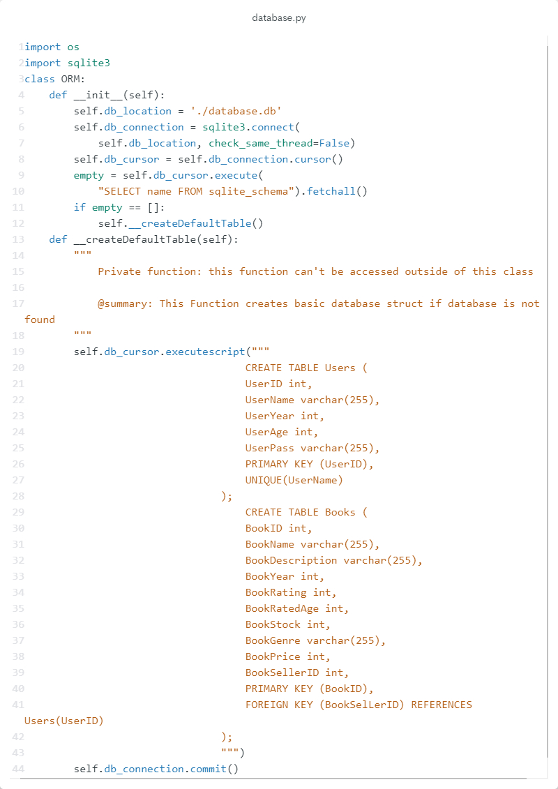

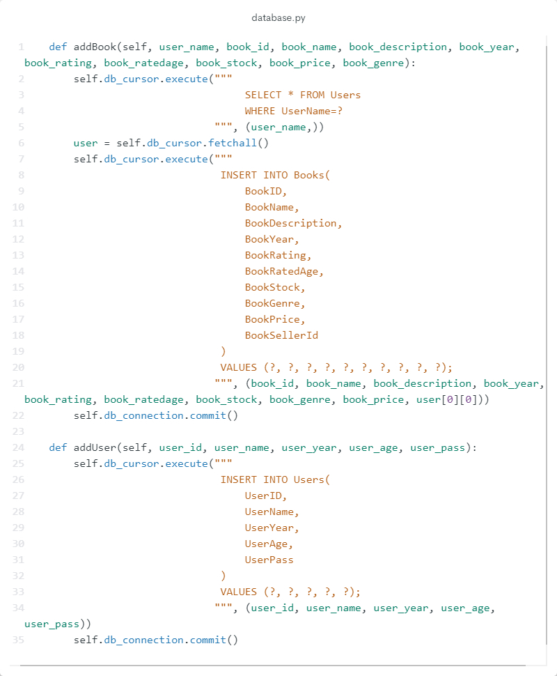

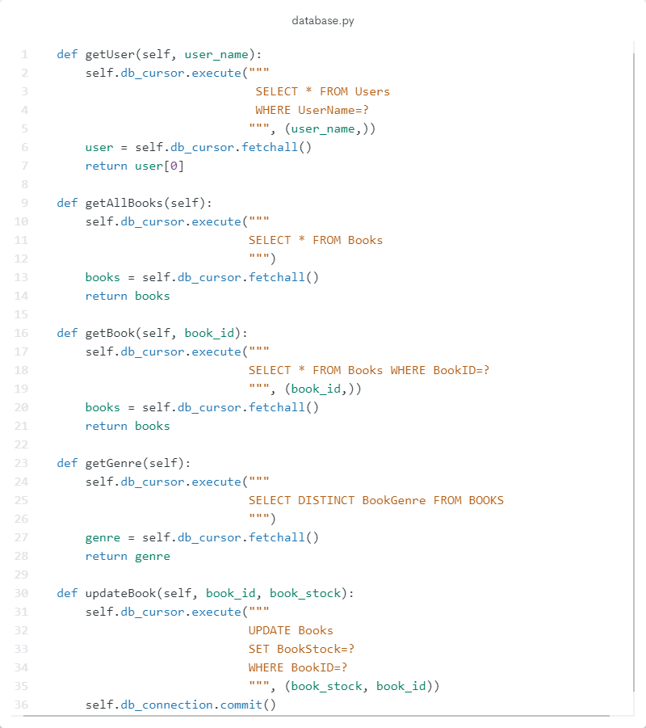

**Output**

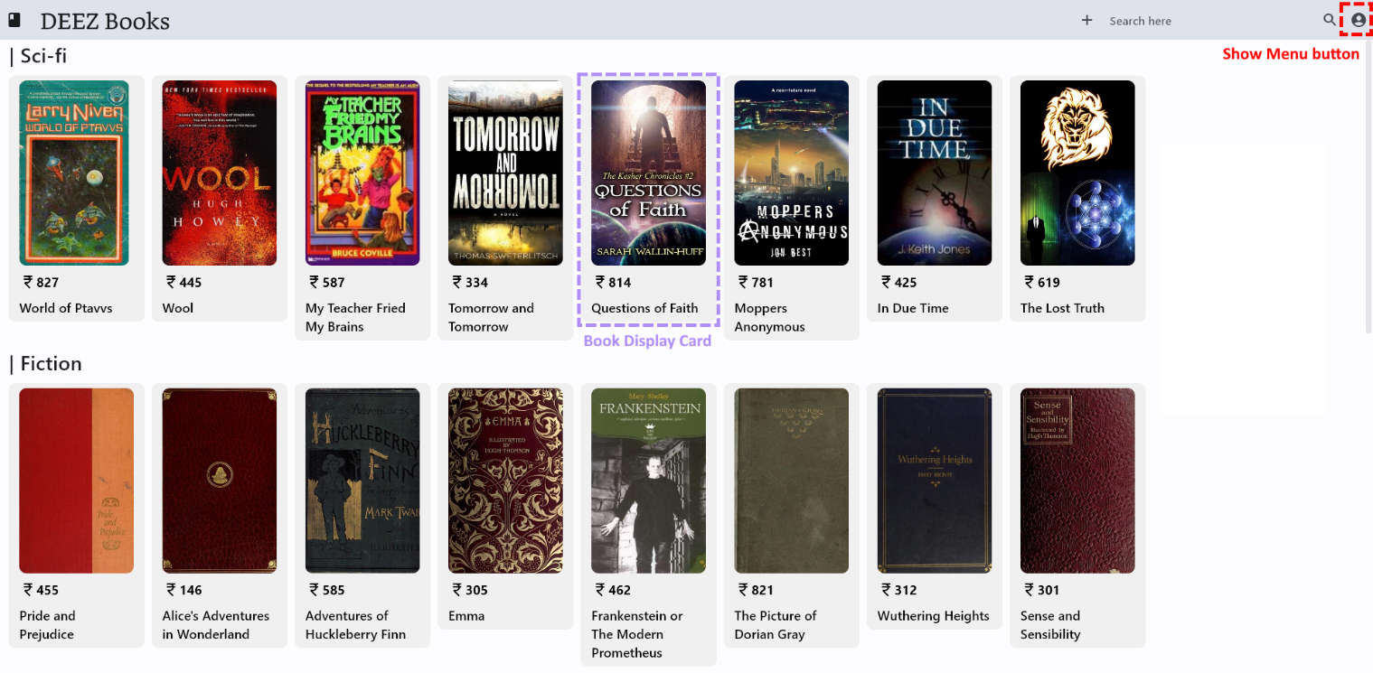Homepage

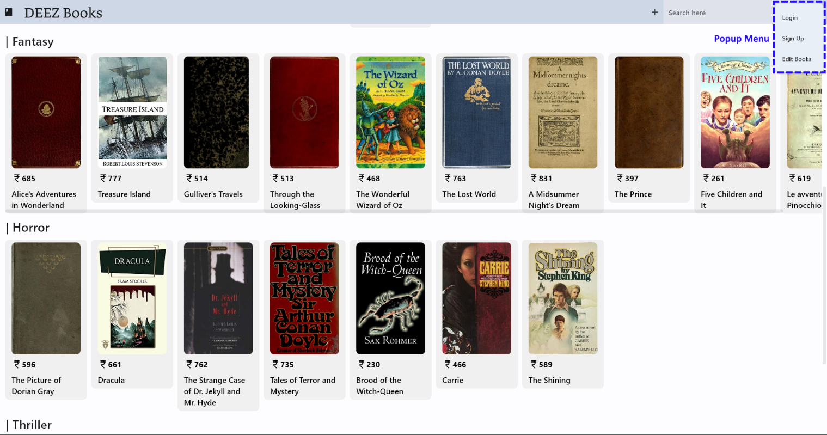

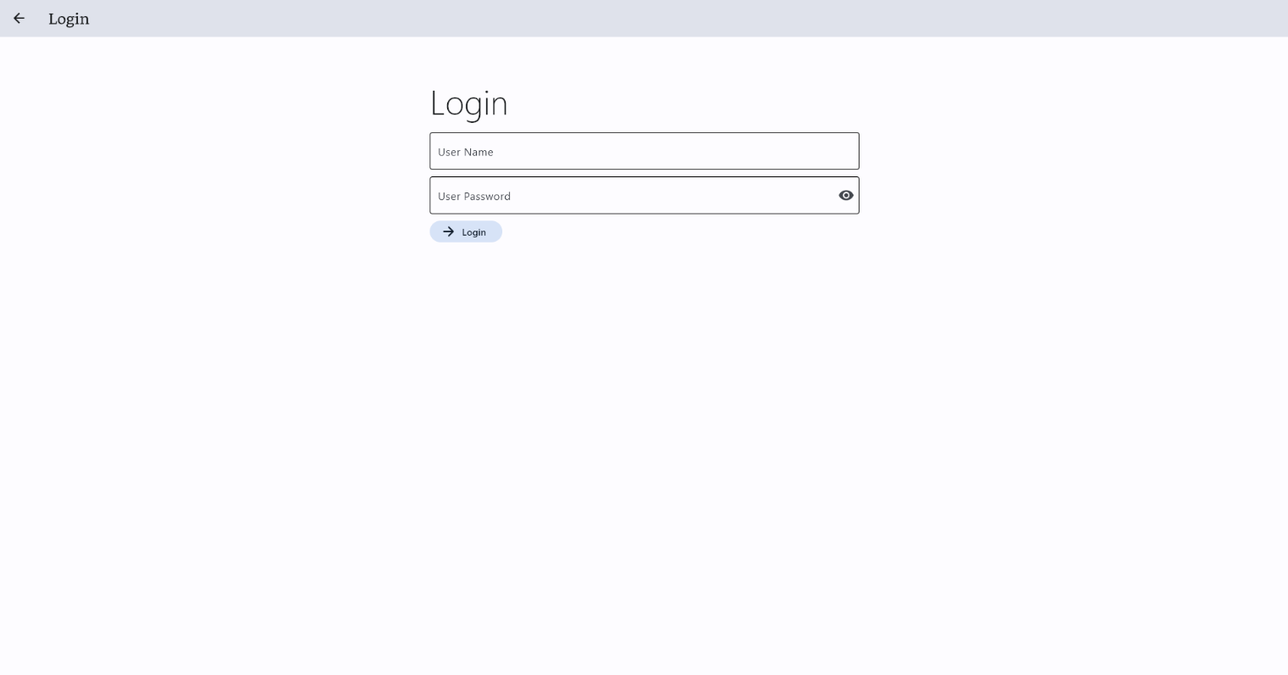Login Page

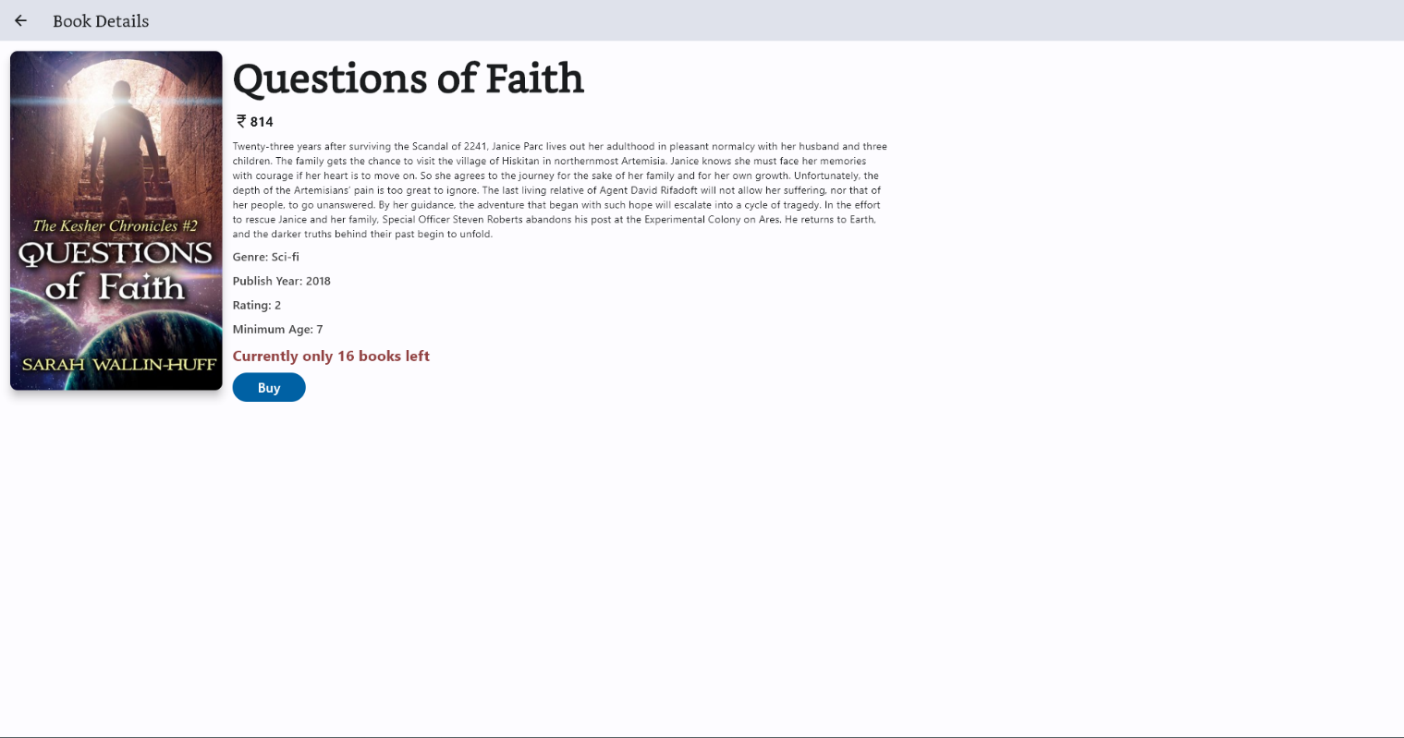Book View

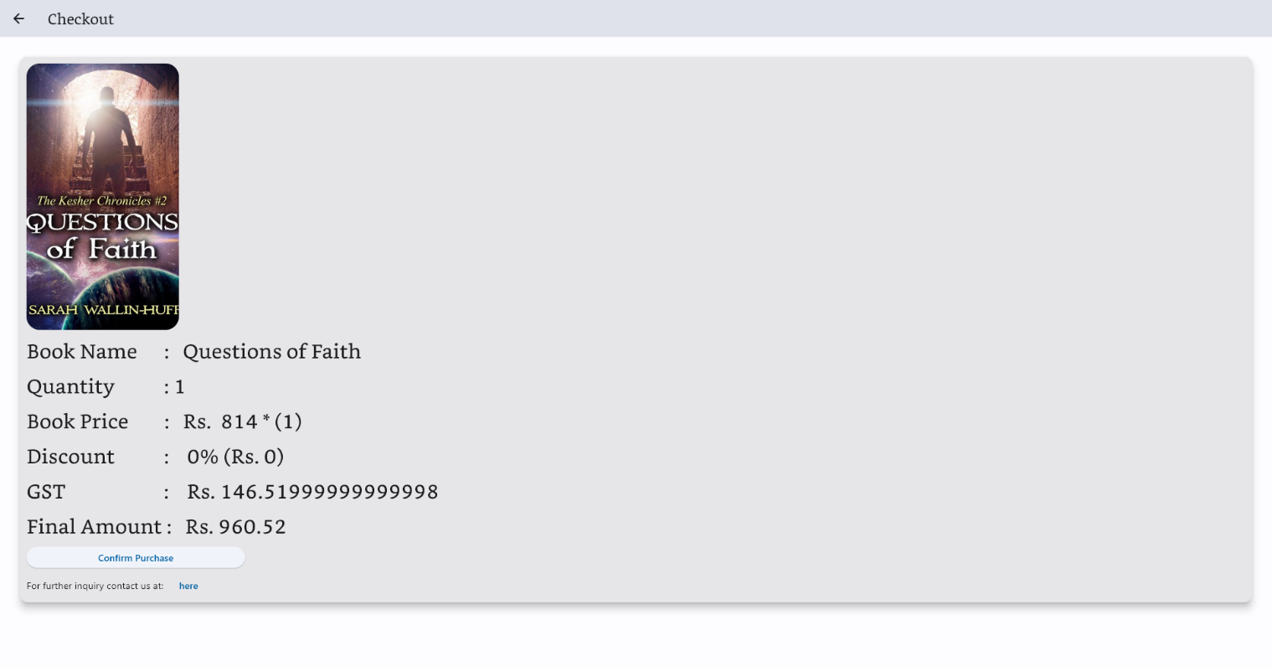Checkout Page

Add Book Page

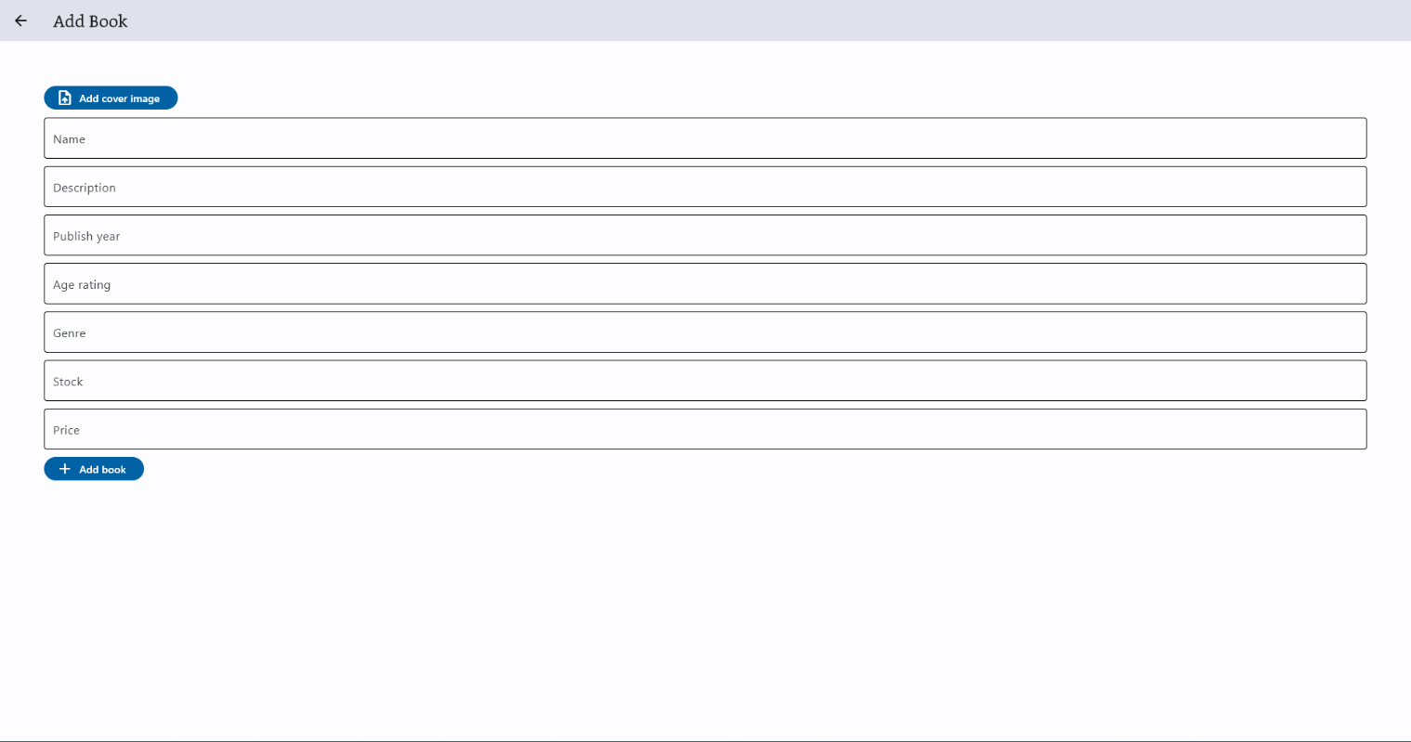

**Conclusion**

Concluding the Book Marketplace project; basic principles of python programming, sql databse and database connectivity were implemented, the project allows the user to search for books, create an account and log in, add books to the marketplace, view book information and purchase books. The application is displayed in form a neat user interface made using the Flet UI framework in python.

**References**

The material/sites/books refered during this project:

* <https://flet.dev/docs/>

{for learning the flet framework}

* Class 12 Computer Science Textbook
* Project source code can be found at <https://github.com/PAN-Project/DeezBooks>